Victory guide to
social media ads
Chiropractic Masters International | www.chiropractic-masters.com | 1.800.781.8127
Using Social/Daily Deals Ads
The use of Daily Deals website advertising such as Groupon, Living Social, Team Buy etc. has resulted in HUGE new patient attraction for clients all over North America. The best part of this type of advertising – it doesn’t cost you! Find as many daily deals sites that service your area and submit your ad using the components below. The examples you’ll find below have produced 150, 170 and up to 250 new patients for my clients without spending a cent!
Note: These companies usually write quirky descriptions for you, but be sure to have the following components present in your final ad!
Components of your social media ads
- A Direct Response Offer. Most Effective From $27 To $47
- Original Price Listed, Or VALUE Of The Deal
- Discount Percentage
- Expiry Date – Within 2 Weeks
- Counter With Number Of People Who Have Purchased Already (Social Proof)
- Best With Bundling With Another Service Like Massage, Decompression, Nutritional Consult Etc.
- What’s Included In The Exam: Exam, Spinal Images, First Adjustment, Report Of Findings, (Anything Included With Bundle)
- Social Media Links (Twitter, Facebook Sharing)
- Short Research Study Points Or Safety Points
- Title Of USP (Unique Selling Proposition)
- Pictures Of Happy People Or People Getting Care
- Limitation To One Person Per Deal
SOCIAL MEDIA AD EXAMPLE:

SOCIAL MEDIA AD EXAMPLE:

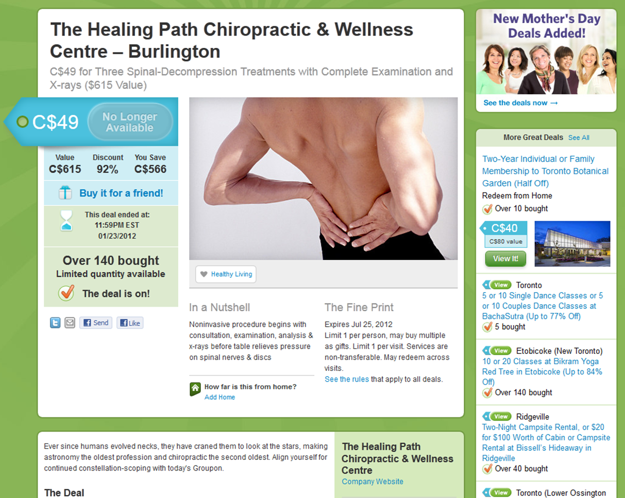

SOCIAL MEDIA AD EXAMPLE:

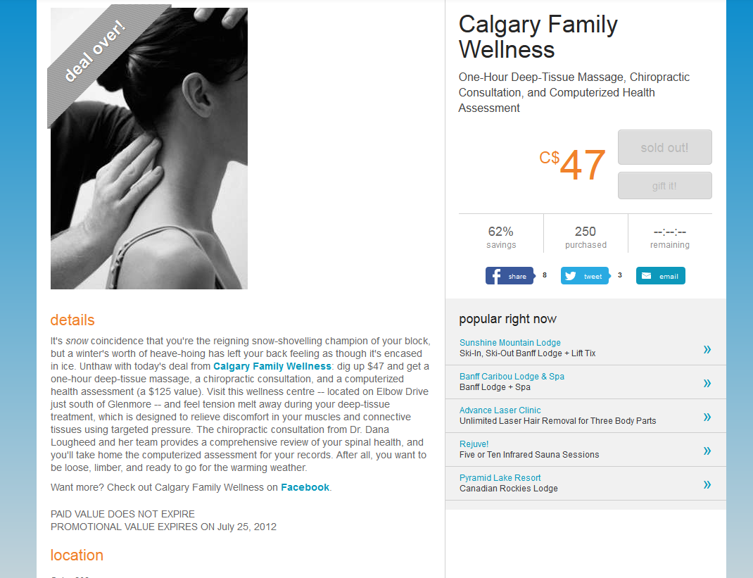

Online www.chiropractic-masters.com Toll Free 1-800-781-8127

